The tables building up the Data Inventory Manager are out of synch

Find out in which table the problem is - Field
SELECT
customdefinedfield.name,
customdefinedfield.cdf_datatype,
customdefinedfield.entitytype
FROM
customdefinedfield
Left Join `field` ON customdefinedfield.cdf_id = `field`.cdf_guid
WHERE
`field`.cdf_guid IS NULL

Note! in this document there are NO instructions on how to fix problems of this kind.

Find out in which table the problem is - CustomDefinedField

SELECT
`field`.property_name,
`field`.fieldtype,
`field`.display_mechanism,
`field`.cdf_guid
FROM
customdefinedfield
Right Outer Join `field` ON customdefinedfield.cdf_id = `field`.cdf_guid
WHERE
customdefinedfield.cdf_id IS NULL AND
`field`.cdf_guid IS NOT NULL AND
(`field`.fieldtype = 'cdf' OR
`field`.fieldtype = 'select_cdf')
ORDER BY
`field`.fieldtype ASC

How to fix second problem
There is row(s) missing in the customdefinedfield. It is NOT recommended to delete them from the field table because they may be referenced from other places in IMSMA:
- saved searches;
- Data Entry Templates;
- user preferences;
- etc.

Which datatype should it have?
In the table field there are three different field type for CDFs:
- cdf
- select_cdf
- text_cdf

select_cdf is ONLY used for single-select and distinguish between radio buttons and combo box (RADIO_BUTTONS and COMBO_BOX as display mechanism).

text_cdf is new for 6.0 and distinguish between area and field (TEXT_FIELD and TEXT_AREA as display mechanism).

SELECT
`field`.field_guid,
`field`.category_guid,
`field`.sequence_number,
`field`.cdf_guid,
`field`.property_name,
`field`.fieldtype,
`field`.display_mechanism
FROM
`field`
WHERE
`field`.cdf_guid = 'c0a8-d801-13302a33727-5c82315b-1e-f7e'

If you do not get any guidance here then next place to get guidance from is the table cdfvalue.

SELECT DISTINCT
cdfvalue.`position`,
cdfvalue.value_type,
cdfvalue.stringvalue,
cdfvalue.numbervalue,
cdfvalue.datevalue,
cdfvalue.organisation_value,
cdfvalue.place_value,
cdfvalue.gazetteer_value
FROM
cdfvalue
WHERE
cdfvalue.cdf_id = 'c0a8-d801-13302a33727-5c82315b-1e-f7e'

If there are values in number, date, organisation, place or gazetteer then you have the answer.
If there are values in string then it could either be a text or a multi-select.

Which you will see in the table allow_value_set.

SELECT
allowed_value_set.allowed_value_set_type,
allowed_value_set.data_type,
allowed_value_set.allows,
allowed_value_set.value
FROM
allowed_value_set
WHERE
allowed_value_set.cdf_id = 'c0a8-d801-13302a33727-5c82315b-1e-f7e'

If you find rows here it is a multi-select (if it was a single-select you would already have identified that in table field).

If you have not been able to identify data type 100% by now then I would use text.

Which item and category did it belong to?

SELECT
category.pojo_parent,
category.name_translation_key,
category.category_guid
FROM
`field`
Inner Join category ON `field`.category_guid = category.category_guid
WHERE
`field`.cdf_guid = 'c0a8-d801-13302a33727-5c82315b-1e-f7e'

- Open table customdefinedfield in Navicat
- Scroll/page to the end

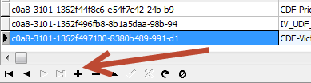

- Click on + button

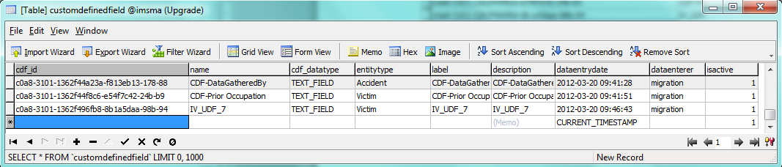

- Copy and paste the cdf_id into the column.
- Name we cannot know so give it e.g. cdf_recreated_qa

- Set the correct value for cdf_datatype and entitytype (see below).

cdf_datatype |  | entitytype *
DATE |  | Accident
GAZETTEER |  | Gazetteer
MULTI_SELECT |  | GEOPOINT
NUMBER |  | Hazard
ORGANISATION |  | HAZARD_DEVICE
PLACE |  | Hazard Reduction
SINGLE_SELECT |  | HAZARD_REDUCTION_DEVICE
TEXT_FIELD |  | Location
 |  | MRE
 |  | Organisation
 |  | Place
 |  | QA
 |  | Task
 |  | Victim
* Note there are more entity types than these but these are the most common used

- Write the same for label and description as you did for Name
- dataentrydate will be set automatically when you save
- dataenterer = migration
- isactive = 1
- Save by moving the cursor to another row.
- Run the queries in ‎1.1 Find out in which table the problem is - Field and ‎1.2 Find out in which table the problem is - CustomDefinedField again.
- If there is now no rows in the result then you have fixed the problem.
- Verify by opening the DIM (you could have done another mistake when you re-created the row in the table customdefinedfield e.g. misspelling of cdf_datatype and entitytype)

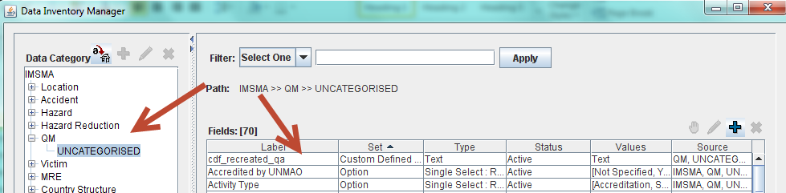

And the CDF is back in the item and category it should be

