Create database manually & Language settings in Navicat

Applies to
- MySQL

Exceptions
No exceptions are known.

Reason
Sometimes you would like to look at one more database than the current you have as imsma. The database should be created in a connection using the database user root.

Solution
- If needed create the root connection.

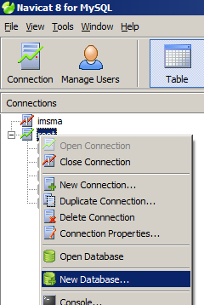

- Right-click on root and choose New database.

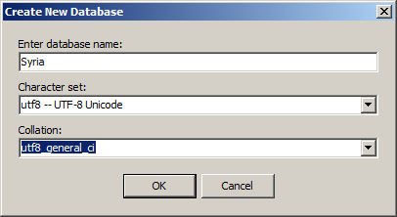

- Enter database name and set Character set & Collation as above.
(utf8 is the last one in the list and uft8 is the first one in the list)

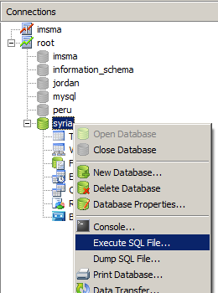

- Click on your new database and activate it. Right-click and choose Execute SQL File

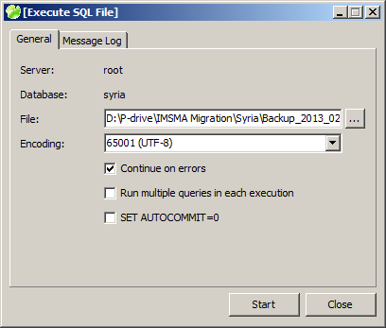

- Locate your dump file and select “Continue on errors”. Click on Start.

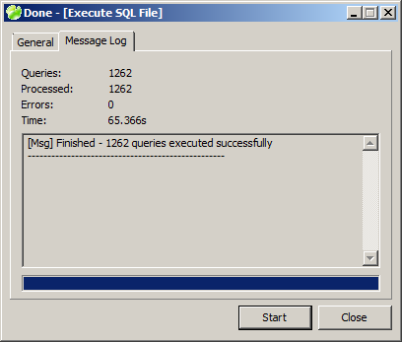

- Wait until the script is executed (100%) and click on Close.

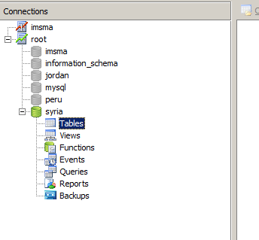
- Navicat does not refresh automatically so right-click on tables and choose Refresh.

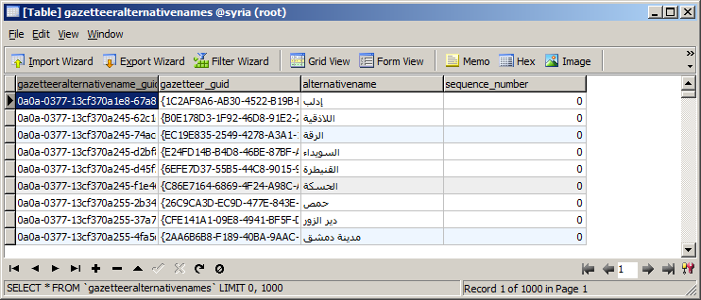
- Open a table and verify that the language seems OK.

