Grey window

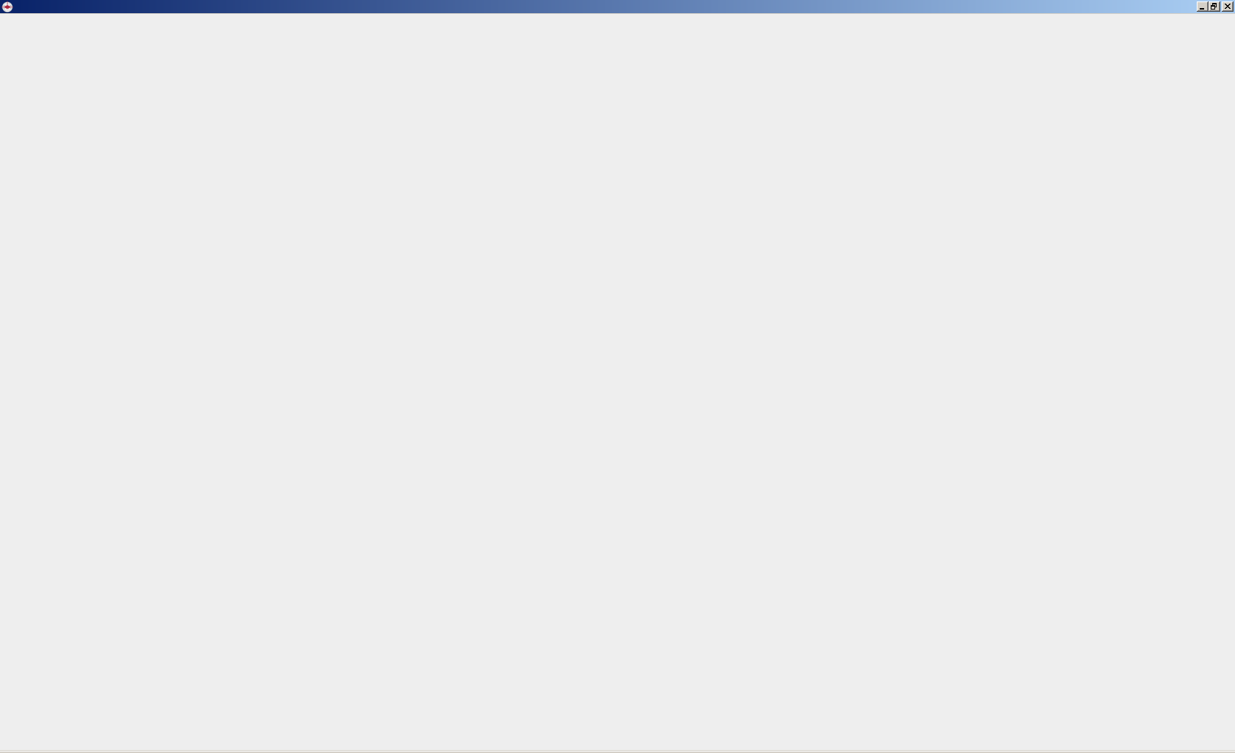

This has been caused by in different 5.x versions and countries:

- corrupted Saved searches

- User preferences in Item pane
e.g. Organisation has been selected for both Hazard and Location
(choosing Geospatial info twice gave another error)

- user-1 had been changed to CMAA

