Release Notes
IMSMA v5.05.00

This document contains information highlighting new functionality, improvements and major fixes implemented for IMSMA v5.05.00 as well as Known Issues and Usability. This document is intended as a quick reference to the major changes and overall functionality of the IMSMA v5.05.00, please see the IMSMA Operation Guide and IMSMA System Administration Guide for more detailed information, helpful hints, and step-by-step “How-to” instructions.

- INSTALLATION AND CONFIGURATION

Installation and Upgrade
New and Improvements
  - ArcGIS 9.3 Upgrade – Please be advised that IMSMA V5.05.00 has upgraded to implement ArcGIS 9.3 runtime engine.
      - ArcGIS 9.3 Installer - The ArcGIS 9.3 runtime engine installer is included and integrated to IMSMA V5.05.00 Installer. Please note that IMSMA is programmed to detect ArcGIS software and version and will take the following action:-
        - If you have ArcGIS runtime engine and/or ArcGIS desktop version 9.2 and less installed on your machine, you will need to de-install them in order for ArcGIS 9.3 installer to run and complete the installation on your machine.
        - If you don’t have ArcGIS installed on your machine, IMSMA will launch the ArcGIS 9.3 installer.
      - “ARCGIS_HOME” is now obsolete – The Installer of ArcGIS version 9.2 and up automatically creates “ARCGISHOME” system variable during the ArcGIS installation. IMSMA is now using the “ARCGISHOME” variable in place of “ARCGIS_HOME”. Thus, IMSMA no longer requires users to manually create the “ARCGIS_HOME” variable.
      - ArcGIS license installation – IMSMA V5.05.00 Installer will automatically install the necessary ArcGIS license as part of the IMSMA installation. Thus, IMSMA no longer requires users to manually install ArcGIS License via the IMSMA Client Configuration Tool.
  - IMSMA TrayLauncher
    - IMSMA TrayLauncher Menu
      - “IMSMA Client” menu item and “iReport” menu item were removed from the IMSMA TrayLauncher. The “Start Client” menu item and the “start iReport” menu item are now available at the first level of the IMSMA TrayLauncher menu – This removes an unnecessary step to start IMSMA Client and iReport.
    - Unified Console – The Unified Console is a menu window is provided to centralize the display of output (stack trace) for IMSMA Client, IMSMA Server, IMSMA TrayLauncher, Backup, and Restore.

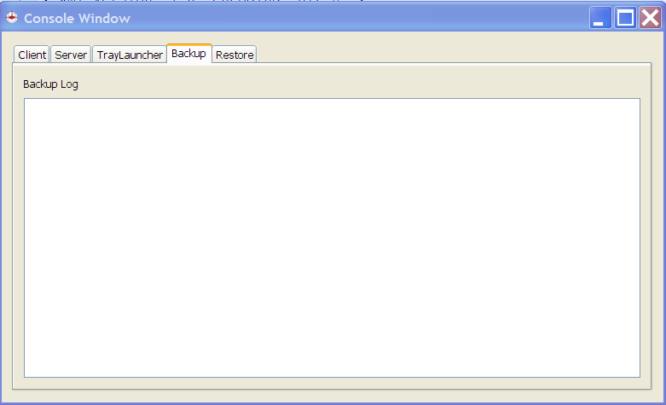

    - System Variables – The Client console now shows the values of System variables used by IMSMA:- IMSMA_HOME, ARCGISHOME, and PATH.
    - Progress bar – Progress bar is provided to display the progress of IMSMA Server Startup, IMSMA Server Shutdown, and Restore.

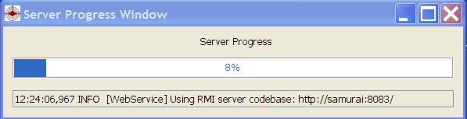

    - IMSMA Client Configuration Tool – The webServiceBaseURL variable has been removed from the IMSMA Client Configuration Tool Window.
    - “Port In Use” Window – An option to shutdown IMSMA Server is provided at the “Port in Use” Window to allow the user to shutdown the IMSMA Server without having to go to the Task Manager to manually end the IMSMA server processor.
    - Database Error Message – IMSMA will display the “Database Error” message when the IMSMA database is missing (not installed) or when mysql service is not up and running.

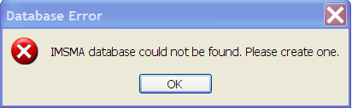

  - 5.05.00 Upgrade – Please be advised that there are major changes in the V5.05.00 Release. If you have a previous version of IMSMA installed, please note the following:-
    - IMSMA Database – If you have a previous version of IMSMA installed, the Upgrade will detect the version of your IMSMA database and upgrade to V5.05.00 accordingly.
Recommendation:- Prior to installing IMSMA V5.05.00, it is a good practice to backup your database and other pertinent IMSMA data via the IMSMA Backup function, and be sure to include IMSMA version as part of the name your backup directory so that if you need to go back to that Backup file, you know what IMSMA version your backup file was created in.
    - IMSMA.mdb – If you have IMSMA.mdb file (sandbox) created in the previous Upgrade will not upgrade your IMSMA.mdb file. You
    - IMSMA.mxd – The IMSMA.mxd file has been updated to include the new IMSMA theme and sub-themes for Task and user defined sub-themes. You will need to re-import your map into IMSMA in order for the new themes/layers to be included in your Map (Your_Map_Name.mxd file).
- New IMSMA Font
  - IMSMA2009.ttf is a new IMSMA font file that must be installed manually for the Task themes to display correctly on the Main Navigation. To install the new IMSMA2009.ttf font, please follow the following steps:-
    - Via Control Panel, navigate to Fonts.
    - Uninstall the IMSMA 2005 Font from the system by deleting it from the Fonts folder.
    - Copy the IMSMA2009.ttf file and paste it to the Fonts folder.
    - You should see the message stating that IMSMA 2009 Font was successfully installed.
- Initial/canned data sets
  - Initial data set comes pre-upgraded to V5.05.00
  - Demo data set comes pre-upgraded to V5.05.00
  - Demo Full data set remains at V5.04.00 – If you run the install_demo_full.bat script, you will need to re-launch the IMSMA TrayLauncher if it’s already running for IMSMA to detect the database version and upgrade it to V5.05.00.
- Improved Upgrade Window – The Upgrade Window has a new look and also shows a Progress Bar.
- Attachment data – In the previous versions of IMSMA, attachment data are stored in the IMSMA database. The new implementation of Attachment in V5.05.00 is to store attachment data as file system on the IMSMA Server. As part of the IMSMA V5.05.00 Upgrade, all attachment data in the IMSMA database will be converted to file system and stored under the IMSMA_HOME\server\attachments directory on the IMSMA server, and the data will be removed from the IMSMA database.

Known Issues
  - Upgrade process may take a long time depending on the size of your database.
  - The default display of the World map is centered at the (0, 0) coordinate but not at the correct scale; thus, it does not default to display the entire World map.
Usability Notes
  - GIS data - If you have IMSMA previous version installed on your machine, you will need to rebuild the following GIS items:-
    - Sandbox must be rebuilt with the IMSMA V5.05.00 Release
    - Map must be re-imported via IMSMA V5.05.00 Release
  - ArcGIS – If you have ArcGIS Desktop version 9.2.x and older installed on your machine, you will need to remove it in order for the ArcGIS 9.3 runtime engine to install. Without ArcGIS 9.3 runtime engine, IMSMA V5.05.00 cannot be executed.

New IMSMA Visual Identity
New and Improved Functionality
  - New IMSMA Logo (image below) should display on all IMSMA Windows.


  - New IMSMA Login Window
    - Implemented the new IMSMA Splash image.
    - User ID and Password fields are left justified.
    - Black color background is replaced with white color.
  - IMSMA About Window
    - Implemented the new IMSMA Splash image.
    - Displays Version and Build information.

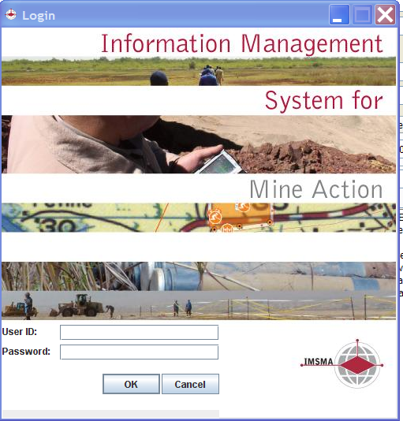

Usability Notes
  - IMSMA Logo on the Login Window gets cut off just by a little when the locale is set to Spanish.

Performance Improvements
Areas of Performance Improvement
Users will notice a great deal of performance improvement in the following areas:-
- Column Picker – Code Optimization was implemented to increase the time to build the Field list at the Column Picker Window.
- Field Report Template List – Code Optimization was implemented to reduce the time to build the Field Report Template list at the Field Report Template list Window.
- Search Manager - Code Optimization was implemented to reduce the time to build the Search list at the Search Manager Window.
Known Issues
- Performance hit continues to be noticed when running IMSMA in a Client-Server environment with a large data set; especially, when the system is being updated with new or edited data.
- View Search Result on Map can be slow.

Usability Notes
- Via IMSMA Client Configuration, setting the ‘AlwaysSynchGeodata’ flag to ‘false’ may help with the performance hit since Map refresh is not automatic and only happens upon user manual request.

New Functionality and Usability Improvements

Search
New and Improvements
- Sub-Object Search – This is an enhancement to the Search function to allow users to search for Object based on data fields of Sub-Object (see list below) as search criteria.
      - Available Sub-Objects for Hazard
        - Munitions (Device)
      - Available Sub-Objects for Hazard Reduction
        - Device Found
        - Impact Survey
        - Interviewee
      - Available Sub-Objects for Victim
        - Received MRE
      - Available Sub-Objects for MRE
        - MRE Detail
      - Available Sub-Objects under Organisation
        - Organisation Accreditation
    - GeoSearch – This function allows users to search for Object based on the Geospatial Data associated with: Locations, Tasks, Hazards, Hazard Reductions, Victims, Accidents, MRE, QC, Places, Organisations and Gazetteers. The GeoSearch functionality allows users to include Geospatial Information as search criteria in a search. Within a search a user can choose to search for objects that are within or outside of a specific Map Extent. The Map Extent is chosen on the map view.
      - Available operators are ‘Inside’ and ‘Outside’
        - Inside - Inside the map extent
        - Outside - Outside the map extent
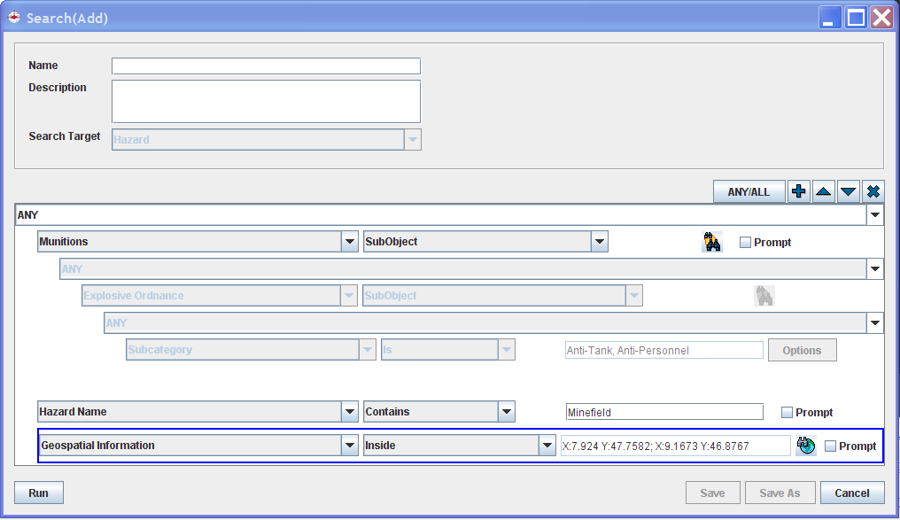
Sub-Object Search

This Search feature allows users to drill down to Sub-Objects and further define search criteria using the data fields from the Sub-Object.
Geo-Search

This Search feature allows users to specify a map extent as a search criteria. Available operators:- “Inside” and “Outside”
Define Map Extent via Lasso function at the Map Display

  - Known Issue
    - When including a sub-object search under a linked object (3 level depth in Searching), you will get an error exception. For example, if you build a Search for Hazards linked to Hazard Reduction that has Device Found of type Anti-Tank, you will get error exception. However, if you build a Search for Hazards that contain Munitions of type Anti-Tank, this Search should work fine.

  - Usability Notes
    - Search containing empty selection on non-text field such as options, date, etc.
      - Unchecked prompt – the Search cannot be saved or run.
      - Checked Prompt – the Search can be saved. However, when it’s run and there’re still empty selection on non-text field, users will get an error message.
    - GeoSearch – When selecting to search ‘Outside’ the map extent, the search results will include everything not inside the map extent including objects with no geospatial data.

Task Management
Task Management is a brand new IMSMA component that provides a basic framework to allow users to manage Task data. A new IMSMA objects called “Task” and “Work Item” will be added to the existing list of Objects in IMSMA. Task will be implemented as IMSMA Base Table and will have functionality and behaviors similar to any Base Table Objects such as Country Structure, Place, Organisation, and Ordnance. Thus, Task will not be entered or managed via Field Report; rather, Task will have its own GUI for data entry. Work Item is a sub-object of Task and can be associated to a Hazard Reduction, a QC, or a MRE. Below is a list of high-level functionality under Task Management:-
- Task Manager
  - Ability to add a new Task
  - Ability to edit or delete a Task and its associated Work Item data
- Associate a Task to other IMSMA objects
  - Task can be linked to one or more Hazards as task objective
  - Work Item can be associated to a Hazard Reduction, a QC or a MRE.
    - Please note that a link between a Work Item and an IMSMA activity-like Object is a one-to-one link.
  - Task can be linked to any IMSMA objects as related information
    - Please note that link as related information has no impact or affect to the Task data as it is treated as reference information.
- Task Manager and Task Editor/View can be accessed from the IMSMA Main Navigation and Object Current Views. “Task Management” Permission is provided to set users as Read Only or Read/Write to Task data.
- Data Inventory Manager is extended to provide users with the ability to manage Custom Option and CDF for Task and Work Item
  - CDFs can be created for both Task and Work Item
  - Custom Options for Task and Work Item can be customized and translated via Data Inventory Manager
- Search functionality is expanded to support the ability to search for Task and Work Item data.
- Reporting and iReport are both expanded to support the reporting of Task and Work Item data

- Ability to view and print a Task
- GIS capability
  - Ability to enter/update geospatial data for Task
  - Ability to display Task theme on the Map
    - In addition to a generic Task theme. 3 Task Sub-Themes are also provided:-
      - By Type
      - By Status
      - By Method
  - Ability to disallow geodata to be entered for Task – Hide the Geospatial widget Tab on the Task Editor Window.
- Ability to assign a Country Structure Area to a Task
Know Issues
- Task’s Related Information – When an object associated to a Related Item of a Task gets deleted from the system, the Related Item still exists on the Task but empty.
- Print function is not available on the Work Item View/Editor Window; thus, users will not be able to print Work Item
Usability Notes
- Print Preview Window and actual printout of the Print function shows buttons and icons
- Ability to export and import Task and Work Item data are not provided.
- Migration Task data is not provided with the V5.05.00 and should be done via field support.

Custom Views
Custom View is a brand new IMSMA capability that allows users to design and choose how and what Current View should appear for Location, Hazard, Hazard Reduction, Accident, Victim, QC and MRE. A user will be able to design the content and appearance of the View and publish it for use throughout the installation. Additionally, functionality will be created to save draft, current and previously published versions of the View for historical purposes or to allow a user to revert to a previous version of the View.
- View Manager – Displays all versions of the Current View for each Object. Views can be published as the Current View that is in use by all users within the system. Previous versions of the Object’s view appear on the table and can be deleted or edited as necessary.
- Default Current View - Upon Installation a default Current View will be available for each Object. This will be the only item in the Object’s View Table and will have a status of Published.
- View Designer – Very similar to Form Template Designer, View Designer allows the user to design the Current View for an Object.

Know Issues
- Undo of dragging items off of view designer places them at the edge of the designer, not their initial position.

Usability Notes
- Unlike Form Template Designer, View cannot be saved locally as a file and shared with other installations. All Views are created and stored in the IMSMA database in the Custom_View table.
- Similar to the Form Template Designer, all data fields including CDFs must be manually placed on a View in order for the data to display on the View. For example, if you create a new CDF for Hazard, you must modify the published View of Hazard to include the newly created CDF field and publish the modified View again in order to see the newly created CDF field.
- Similar to the Form Template Designer, Label of data fields will be displayed as they’re seen on the View Designer regardless of what locale setting you are in when you view the Current View. For example, if your published View (Current View) of the Hazard object contain the Vegetation Category data field, and the Label for this field is “Vegetation Category: “, then you will see the word “Vegetation Category: “ as the label of this data field regardless of what language your system is set to. However, the enumeration value (Bush, Tree, Stump, etc.) of the Vegetation Category field will be displayed according to the locale setting, given that the translation is provided for this data field.

Main Navigation
New and Improved Functionality
- Column Picker on the Data Pane – This enhancement allows users to customize what data fields to display on the Data Pane on the Main Navigation.
- Task
  - Task Theme – Task theme is a newly added IMSMA theme to allow users to turn on/off Task theme from the Map display.
  - Task tab on the Data Pane – Task tab is a newly added tab to the Data Pane on the Main Navigation Window. The Task tab should work the same way as other tabs

Know Issues
- Geospatial information is available at the Column Picker; however, when selected Geospatial information field to be displayed on the list, this can cause performance issue or strange display behavior. Recommendation - Avoid selecting the Geospatial information field at the Column Picker if possible.

Usability Notes
- Country Structure Area is not a required field for Task. Thus the list of Task on the Main Navigation may not match the list of Task on the Task Manager Window.
- Geospatial data entry can be hidden from the users via the Task Management Configuration. However, Task theme will remain listed as one of the IMSMA themes on the Map display. Also if at one point, geospatial data were allowed to be collected and entered for Task, you will continue to see Task on the Map display if the previously entered geospatial data didn’t get cleared out and the Task theme turned on.

Single Select Combo Box Option
The Single Select Combo Box Option is a new functionality that allows users to choose how a Single Select Data Element should appear on Field Report Template. Currently Single Select Data Elements appear on the Field Report template as radio buttons. Changes were made to the following areas to allow the user to pick how a single select option field should be displayed:-
- Data Inventory Manager Window is updated to show the Selection Display default for each Single Selection data element in the “Type” column. The Selection Display is chosen on the Custom Options window described on the next window.

- If no selection has been specified on the Custom Options window of the Single Select window the default is “Radio Button” and the Type column should reflect that.
- The Selection Display functionality will appear on every Single Select Data Element regardless of whether the Data Element is a Custom Defined Field or not.
- CDF Editor Window is updated to allow the user to determine the default behavior of the specified CDF Single Select Data Element when added to a Field report Template on the Form Designer Window.
- Form Designer - Component Property Editor Window is update to allow the user to change the Selection Display Option as a Combo Box or as radio buttons.

XLS/CSV Import (GUI for Migration)
The XLS/CSV Import functionality provide the capability to import field report data or base table data in the XLS or CSV file format into IMSMA. The XLS/CSV Import function is the graphical user interface to the IMSMA Migration API. Thus, before importing data in XLS or CSV format, system administrators must first set up mapping files that specify how the data fields in the .xls/.csv files relate to the fields in IMSMA, the import order, import logic and business rules and any data normalization that may be required for the import
- 3 parameters are required to execute this function:-
  - Import Ordering File – The file that provides information on what order and how data should be processed
  - Process Directory – Directory where migration mapping files are located
  - Import Data Directory – Directory in which XLS/CVS data are located.
- XLS/CSV Import Result Window – The XLS/CSV Import produces the same log files Migration does. However, the XLS/CSV Import Results Window is provided at the end of the Import to display the content of migration.log, migration_errors.log, and migration_dataissues.log in 3 separate panels for your convenience. The log files are also generated and can be found under the IMSMA_HOME\migration directory. Below is the screenshot of the XLS/CSV Import Results Window.

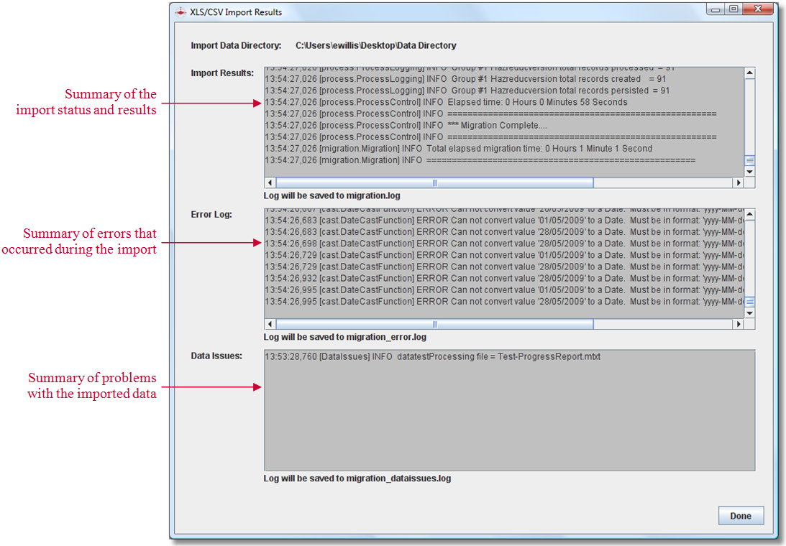

Usability Notes
  - As mentioned above, the XLS/CSV Import function is an interface to the Migration, running this function multiple times on the same data set (same excel spreadsheet) may result in data duplication and data integrity.

Attachment
New and Improved Functionality
- New Attachment implementation – In the previous versions of IMSMA, attachment data are stored in the IMSMA database. The new implementation of Attachment in V5.05.00 is to store attachment data as file system on the IMSMA Server. As part of the IMSMA V5.05.00 Upgrade, all attachment data in the IMSMA database will be converted to file system and stored under the IMSMA_HOME\server\attachments directory on the IMSMA server, and the data will be removed from the IMSMA database.

Known issues
  - Migration – Attachment function in the Migration API is broken and thus attachments cannot be migrated with the IMSMA V5.05.00 Release. This issue is in the queue to be addressed in the V5.05.XX Patch.
Usability Notes
  - Attachment data can only be backed up and restored on IMSMA Server machine. If your machine is set up as Client only (isClientOnly is set to ‘true’), then Attachment data cannot be backed up or restored.
Link to Organisation
New and Improved Functionality
- Added the ability to associate Organisation to Location, Hazard, and Accident – In the previous versions of IMSMA ng, Organisation link were available only to Hazard Reduction, MRE, Victim, and QC objects. As of IMSMA V5.05.00, Organisation can be associated to all IMSMA Domain Objects including Location, Hazard, and Accident.
  - Form Designer was expanded to include the Organisation widget for Location, Hazard, and Accident.
  - Search was expanded to support searching for Location, Hazard, and Accident based on Organisation.
  - iReport - Hazard data source, Accident data source, and Location data source were expanded to include Organisation field.
  - Field Report Export was expanded to handle the export of Organisation association for Hazard, Accident, and Location.
  - Field Report Import was expanded to handle the import of Organisation association for Hazard, Accident, and Location.
  - The new Current View shall also support the display of Organisation for Hazard, Accident, and Location objects.

Usability Notes
- Default form templates for Hazard, Location, and Accident do not include Organisation field.

Form Template Designer
New and Improved Functionality
- Use of published form template – The user can now choose a published form template and drag it over to the Form Template Designer for edit, save, and publish. At the Field Report Template Designer Window, published form templates are listed under the new “Published Templates” folder.
- Delete a published form template – The user can now delete a published form template that is marked as “inactive” and not in use.
- Page Scrolling – This feature is provided to allow users to scroll across multiple pages to move selected data widgets to the target page. Previously, the limitation was that the user had to move data widgets to the next page (one page at a time) until reaching the target page.
- Page Formatter – Saved margins, page orientation, and page size are persisted and applied to a form at the Form Template Designer. Margins are now visible.
- Multiple CDFs – This is a fix. Previously when you drag multiple CDFs of the same type to a form that contains multiple objects of the same type, all CDFs goes to the 1st Object and it was not possible to move or distribute the CDFs to each object on the form. Now the user can move and distribute CDFs to each object on the form via the Logical Tree.

Known issues
- When a form template is re-opened, data widgets may get placed in a slightly different position than its original position. It may help if each page of a form has a page header and a footer to mark the beginning and ending of the page.

Field Report Data Entry and Approve/Un-Approve
New and Improved Functionality
- Field Report Un-approve
  - Users can now un-approve the following field reports:-
    - A field report containing MRE and MRE Detail(s). All items reconciled as New. All MRE Details reconciled as New and to the MRE that is on the same field report.
    - A field report containing a Location and other IMSMA object(s). All items reconciled as New. All non-Location Objects reconciled as New and to the Location that is on the same field report.
    - A field report containing non-Location Object(s) with a Location created on-the-fly. All items reconciled as New. All non-Location Objects reconciled as New and to the Location created on-the-fly.
  - Field Report Unapprove Failed Window – When a field report cannot be approved due to the dependencies (links to other objects), the Field Report Unbapprove Failed Window will display to provide a list of objects that are linked to the object(s) on the Field Report. The user can double-click each item to open the current view of the item. Below is a snapshot of Field Report Unapprove Failed Window.

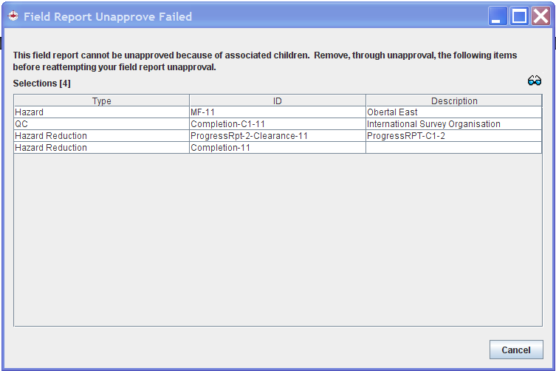

- Entering GeoData
  - Point Fixed By – The Point Fixed By combo box is provided at the Point Editor Window to allow users to enter a Point Fixed By value for a point. The Point Foxed By value is also handled at the Field Report Export and Field Report Import functions.
  - Bearing and Distance – Users can now enter/edit bearing and distance values regardless of what locale the system is set to.

Known issues
- PointFixedBy data field is not supported in the IMSMA Mobile. Thus, if a field report was entered via IMSMA but then get edited by IMSMA Mobile, the value entered for the PointFixedBy data field may be lost.

Usability Notes
- Coordinates in decimal degrees – If you are working on a system that has locale set to Spanish or French, you will get validation error (the entries would turn pink color and there should be validation errors thrown at the Client console) on coordinates in decimal degrees that were entered during the system was set to English. This is because English uses ‘.’ to represent a decimal point and Spanish or French uses ‘,’. This is true the other way around.
- LocalID change on existing Object – When a change is made to the LocalID field on an existing Object (this is done via Field Report Entry), bulk Field Report Approve may fail on those field reports that refer (reconciliation and/or link) to the Object with modified LocalID. This is because LocalID field is used to match an Object during the Import processing.
- Data entry on numeric fields (including CDF Numeric field)
  - Integer – For data fields defined as integer, value is entered and displayed based on the locale setting. Number format is reinforced at the time of typing. Neither ‘.’ nor ‘,’ is allowed to be entered for an integer field. Examples of integer fields are Number of persons involved, Number of audience, etc.
  - Float/Double – For data fields defined as float or double, numeric value is entered and displayed based on the locale setting. Number format is reinforced at the time of typing. For instance, if your system is set to Spanish and you are entering data for Area Size, you will force to enter only numbers and a ‘,’ for decimal point. Examples of float and double fields are Area Size, Depth, Estimated Width, Estimated Length, Azimuth, Hour Spent, Distance to Nearest Town, % Female, % Male, etc.
  - Time – Data fields such as Time to Hospital, Time to Medical Facility, etc. can only be entered either in HH:MM:SS format or a numeric value with ‘.’ for decimal point regardless of locale setting. Validation on these data fields occurs at the Field Report Save call.
  - The following data fields seem like a numeric field but they're alpha-numeric field:- Estimated work days and Age.

List of all Defects and Change Requests addressed in the IMSMAv5.05.00 Release
Below is the list of all defects and change requests addressed during the development of IMSMA v5.05.00 Release.
ID | Description | Priority | Type | Test Results
5430 | IMSMA Visual Identity | Priority 1 | Client Change Request | PASSED
5428 | Provide a way to import non-maXML or non-mdml field report data | Priority 1 | Client Change Request | PASSED
5224 | Usability issue with "Combo box" field with large option set -- Not practical to place all the options on a Form | Priority 1 | Client Change Request | PASSED
5231 | Column Picker on Main Nav | Priority 2 | Client Change Request | PASSED
4087 | No scrolling when dragging data widgets across pages in FR designer | Priority 2 | Client Change Request | PASSED
3202 | Margins need to be visible on the Form Designer | Priority 3 | Client Change Request | PASSED
5448 | ArcGIS_Home variable |  | Change Request | PASSED
5834 | Should be warned before deleting a View |  | Change Request | PASSED
5407 | Ability to Customize Obejct View | Priority 1 | Change Request | PASSED
5440 | ArcGIS 9.3/9.4 | Priority 1 | Change Request | PASSED
5437 | Attachment rework | Priority 1 | Change Request | PASSED
5432 | Organisation linked to other objects | Priority 1 | Change Request | PASSED
5837 | Remove "Does not support OS" message | Priority 1 | Change Request | PASSED
5051 | Search on Subobjects | Priority 1 | Change Request | PASSED
5423 | Search within a Lasso | Priority 1 | Change Request | PASSED
5424 | Task Management | Priority 1 | Change Request | PASSED
4660 | Ability to delete inactive published templates | Priority 2 | Change Request | PASSED
3370 | Add guid field to Object Views | Priority 2 | Change Request | PASSED
5295 | All windows that display all IMSMA object fields are slllooooww | Priority 2 | Change Request | PASSED
4983 | Data Entry Date not a valid column (or filter field) for Hazards | Priority 2 | Change Request | PASSED
5861 | Default installation directory should be set to "C:\IMSMAng" | Priority 2 | Change Request | PASSED
5021 | iReport uses the JRField name for subreport headings, not description like the main report | Priority 2 | Change Request | PASSED
5323 | May need a more descriptive error message when mixing alpha-numeric characters in certain field report fields | Priority 2 | Change Request | PASSED
4360 | Multiple Select fields in Data Inventory Manger to move to a new Folder versus one at a time | Priority 2 | Change Request | PASSED
4337 | Point widget should include point fixed by drop down list | Priority 2 | Change Request | PASSED
5076 | Search fields must be filled in, even if they are set for prompting | Priority 2 | Change Request | PASSED
5817 | Should not be able to create an empty View | Priority 2 | Change Request | PASSED
5807 | Text Area scrolling in current view incorrectly moves entire border | Priority 2 | Change Request | PASSED
5139 | There should be a run button on the Impact Scoring Template add/edit window | Priority 2 | Change Request | PASSED
5636 | Add GUID Fields on Current Views | Priority 3 | Change Request | PASSED
5698 | Creating a new tab in View Designer should bring that tab to the front | Priority 3 | Change Request | PASSED
3448 | Display System Variable Values in Client Log at Startup | Priority 3 | Change Request | PASSED
5553 | Move addToPrintable() from TaskEditorView to TaskPageable | Priority 3 | Change Request | PASSED
5464 | Need a descriptive error message when loggin in without installing database | Priority 3 | Change Request | PASSED
4727 | Parent organisation is on competencies tab of organisation window | Priority 3 | Change Request | PASSED
5556 | Task Status - Include Date and Time on Update Date | Priority 3 | Change Request | PASSED
5401 | Z/elevation column in Points table and Polygons table | Priority 3 | Change Request | PASSED
5498 | Cannot Approve Field Report from Field Report Editor window | Show-Stopper | Defect | PASSED
5829 | Cannot open the same object view for the second time | Show-Stopper | Defect | PASSED
5783 | Error prints on client console after restoring afghan data | Show-Stopper | Defect | PASSED
5830 | Exception thrown when creating a custom view for hazard reduction that include all the fields for the following categories (uncategorised, interviewee, impact survey). | Show-Stopper | Defect | PASSED
5561 | Form Designer - Logical Tree not displaying | Show-Stopper | Defect | PASSED
5559 | Get errors when try to display a Currewnt View that has CDFs on it. | Show-Stopper | Defect | PASSED
5593 | IMSMA really slow | Show-Stopper | Defect | PASSED
5721 | Search on GeoSearch with Link criteria did not return expected results. Summary of instructions below; Create two hazards and two accidents. Each hazard links to a different accident. Create a GeoSearch that includes both hazards and add additional sea | Show-Stopper | Defect | PASSED
5664 | Theme manager does not show icons on the map for the following types. (Hazard Reduction, Accident, Victim, MRE, QC, Country Structure) I know it currently works correctly for (Location & Hazard). There are few other themes that are unaccounted for. (Ta | Show-Stopper | Defect | PASSED
5775 | Unable to reconcile CDFs | Show-Stopper | Defect | PASSED
5507 | "Type of Accident" Combo Box setting does not get used by Field Report Template Designer | Priority 1 | Defect | PASSED
5805 | A Task can be deleted even if it is a Related Item for another Task | Priority 1 | Defect | PASSED
5795 | Able to add alpaha characters for Number CDF for Places | Priority 1 | Defect | PASSED
5737 | Able to drag Received MRE subobject onto Victim tab in View Designer | Priority 1 | Defect | PASSED
5452 | Accident Linked to Victim with multiple links Import Issue | Priority 1 | Defect | PASSED
5525 | Add icon is disabled on DIM | Priority 1 | Defect | PASSED
5841 | Adding a Country Structure Area display duplicates | Priority 1 | Defect | PASSED
5506 | Adding first Handheld Template generates errors | Priority 1 | Defect | PASSED
5793 | Adding Handheld template with Date widget is not displaying correctly | Priority 1 | Defect | PASSED
5589 | After Restore completes, Tray Launcher should close | Priority 1 | Defect | PASSED
5622 | An error occurred, Please contact you vendor | Priority 1 | Defect | PASSED
5671 | Appears the GeoSearch function includes hits that aren't in the selected map extent | Priority 1 | Defect | PASSED
5393 | Approving from the workbench throws an exception | Priority 1 | Defect | PASSED
5688 | Attachments are not included when Exporting | Priority 1 | Defect | PASSED
5598 | Can't approve Hazard FR with Device | Priority 1 | Defect | PASSED
5713 | Cannot drag items from Tool folder onto subobject tabs in Custom View | Priority 1 | Defect | PASSED
5647 | Cannot edit Text Area/Field size on Field Report Template Designer | Priority 1 | Defect | PASSED
5392 | Cannot Unapprove an MRE Field Report that includes an MRE Detail | Priority 1 | Defect | PASSED
5638 | CDFs are not translated at Impact Scoring | Priority 1 | Defect | PASSED
5859 | Client Console displays incorrect variable name "ARCHENGINE_HOME" | Priority 1 | Defect | PASSED
5496 | Column picker incorrectly shows sub-objects/other "excluded from table" data | Priority 1 | Defect | PASSED
5207 | Column Picker is sllllloooooowwww | Priority 1 | Defect | PASSED
5842 | Combo Box CDF value is not displaying on imported Field Reports | Priority 1 | Defect | PASSED
5528 | Como Box to Radio button options changes & persistence issues | Priority 1 | Defect | PASSED
5699 | Component Property Editor issues | Priority 1 | Defect | PASSED
5700 | Component Property Editor should show Data Element name for fields | Priority 1 | Defect | PASSED
5497 | Coordinate format error with distance/bearing points (relative poitns) | Priority 1 | Defect | PASSED
5534 | Current View - error if enums on View | Priority 1 | Defect | PASSED
5777 | Current View table printing cuts off rows, doesn't print Hazard Description | Priority 1 | Defect | PASSED
5655 | Current view window for hazards display an error when opening and field report count doesn't display | Priority 1 | Defect | PASSED
5719 | Custom Current View, various buttons in disabled state | Priority 1 | Defect | PASSED
5855 | Distance and Bearing values not shown when a pointed was entered in Spanish | Priority 1 | Defect | PASSED
5696 | Dropping invalid items onto Subobject tab gives incorrect message in View Designer | Priority 1 | Defect | PASSED
5846 | Editing Combo Box options for a CDF shows option name as java object name | Priority 1 | Defect | PASSED
5673 | Error displaying subobjects tab on Current View when no subobjects exist | Priority 1 | Defect | PASSED
5599 | Error executing iReport for Organisation basic fields | Priority 1 | Defect | PASSED
5603 | Error executing iReport for Place | Priority 1 | Defect | PASSED
5605 | Error executing iReport for Task basic fields | Priority 1 | Defect | PASSED
5609 | Error executing iReport for WorkItem basic fields | Priority 1 | Defect | PASSED
5644 | Error in console when adding Handheld template with text CDFs | Priority 1 | Defect | PASSED
5581 | Error opening any Victim Views | Priority 1 | Defect | PASSED
5487 | Error retrieving pojos using main nav column picker (cdf issue?) | Priority 1 | Defect | PASSED
5802 | Error running report with CDFs when objects have no CDF values | Priority 1 | Defect | PASSED
5825 | Error when entering point data via bearing/distance | Priority 1 | Defect | PASSED
5504 | Errors creating handheld forms from combo box widgets | Priority 1 | Defect | PASSED
5490 | Export Options/Column Picker window Issues for Workbench window | Priority 1 | Defect | PASSED
5602 | Failed approval of Hazard FR opened from workbench | Priority 1 | Defect | PASSED
5476 | Field elements selection issue on DIM window | Priority 1 | Defect | PASSED
5613 | Field report save failed for Accident | Priority 1 | Defect | PASSED
5774 | FixedBy data field does not get persisted. | Priority 1 | Defect | PASSED
5059 | Float search is not accurate when using numbers that contain decimals | Priority 1 | Defect | PASSED
5563 | Form Designer - Error on Undo of Deletion of Data Elements | Priority 1 | Defect | PASSED
5192 | Form designer adds same CDF to same object multiple times rather than creating new object/index. | Priority 1 | Defect | PASSED
5808 | Forms with Single Select Combo-Box CDF publish ISSUE | Priority 1 | Defect | PASSED
5582 | Geospatial widget text areas editable/unpopulated in Custom View Display | Priority 1 | Defect | PASSED
5642 | Handheld table name is not translated | Priority 1 | Defect | PASSED
5682 | Hazard Current View does not have Task icon | Priority 1 | Defect | PASSED
5749 | Hazard Reduction "Type" field is not displaying correctly on statistics tab | Priority 1 | Defect | PASSED
5577 | Hazard Reduction Template Publish Fail | Priority 1 | Defect | PASSED
5809 | Import Issue retrieving Geodata with no Fixed By value | Priority 1 | Defect | PASSED
5804 | IMSMA About window doesn't show text | Priority 1 | Defect | PASSED
5619 | IMSMA Backup Error | Priority 1 | Defect | PASSED
5633 | IMSMA does not save edits made to CDFs in the DIM | Priority 1 | Defect | PASSED
5764 | In task statistics tab, "as of" datetime icon is incorrect and uses the map refresh icon and tooltip | Priority 1 | Defect | PASSED
5562 | iReports - Import Data Source | Priority 1 | Defect | PASSED
5521 | Issues on Option changes and persistence Radio Button to Combo Box | Priority 1 | Defect | PASSED
5460 | Issues with Saving a Search | Priority 1 | Defect | PASSED
5470 | Issues with Sub-object search that has no search conditions | Priority 1 | Defect | PASSED
5789 | JMS Error creating a Country Structure Area on Initial.bat | Priority 1 | Defect | PASSED
5736 | Last Updated time not changed when view is published | Priority 1 | Defect | PASSED
5755 | Link Table in Custom View incorrectly repeats values | Priority 1 | Defect | PASSED
5838 | Main navigation Tab counts are not updated when results are passed from search | Priority 1 | Defect | PASSED
5182 | MGRS Coordinate Reference System is missing | Priority 1 | Defect | PASSED
5744 | Missing related item ID and name for Explosive ordnance. | Priority 1 | Defect | PASSED
5728 | MRE view with MRE Details tab cannot open | Priority 1 | Defect | PASSED
5686 | Multi-Select values on Current View are not translated | Priority 1 | Defect | PASSED
5570 | No Permissions setup for View Manager | Priority 1 | Defect | PASSED
5756 | On place editor, all CDF text, number, and date fields are unedittable | Priority 1 | Defect | PASSED
5779 | Organisation field is required to be filled in for Search Save even if prompt is selected | Priority 1 | Defect | PASSED
5611 | Organisation Icons not appearing on map | Priority 1 | Defect | PASSED
5426 | Page formatting on saved Form does not get applied at Form Designer | Priority 1 | Defect | PASSED
5844 | Pick Country Structure for Related Item table is blank | Priority 1 | Defect | PASSED
5641 | Place Editor removes Type when opening | Priority 1 | Defect | PASSED
5778 | Place is editable if user only has View permission | Priority 1 | Defect | PASSED
5474 | Point Fixed BY values doesn't display in Point/Poly tables | Priority 1 | Defect | PASSED
3695 | Ports Already In Use | Priority 1 | Defect | PASSED
5816 | Possible memory leak warning. | Priority 1 | Defect | PASSED
5600 | Print View does not work in Location view | Priority 1 | Defect | PASSED
5488 | Printing Main Nav data can be wrong or fail when different columns are selecting using column picker | Priority 1 | Defect | PASSED
5703 | Problem changing Combo Box option text | Priority 1 | Defect | PASSED
5477 | Prompt mode for SubObject Search | Priority 1 | Defect | PASSED
5694 | Question does not show up as a data element for Interviewee in View Designer | Priority 1 | Defect | PASSED
5742 | Received MRE data on Victim current view only does not repeat to show all subojbects | Priority 1 | Defect | PASSED
5548 | Related Item empty when selected an Ordnance | Priority 1 | Defect | PASSED
5492 | Restore without Attachemnt Error | Priority 1 | Defect | PASSED
5459 | Saved Search does not persist as it was saved | Priority 1 | Defect | PASSED
5120 | Search by links appears to be using inner join vs left/right join | Priority 1 | Defect | PASSED
5653 | Search for Link - criteria not persisting | Priority 1 | Defect | PASSED
5657 | Search using Country Structure target displays blank screen | Priority 1 | Defect | PASSED
5193 | Searching across links doesn't work correctly with number values | Priority 1 | Defect | PASSED
5426 | Page formatting on saved Form does not get applied at Form Designer | Priority 1 | Defect | PASSED
5844 | Pick Country Structure for Related Item table is blank | Priority 1 | Defect | PASSED
5641 | Place Editor removes Type when opening | Priority 1 | Defect | PASSED
5778 | Place is editable if user only has View permission | Priority 1 | Defect | PASSED
5474 | Point Fixed BY values doesn't display in Point/Poly tables | Priority 1 | Defect | PASSED
3695 | Ports Already In Use | Priority 1 | Defect | PASSED
5816 | Possible memory leak warning. | Priority 1 | Defect | PASSED
5600 | Print View does not work in Location view | Priority 1 | Defect | PASSED
5488 | Printing Main Nav data can be wrong or fail when different columns are selecting using column picker | Priority 1 | Defect | PASSED
5703 | Problem changing Combo Box option text | Priority 1 | Defect | PASSED
5477 | Prompt mode for SubObject Search | Priority 1 | Defect | PASSED
5694 | Question does not show up as a data element for Interviewee in View Designer | Priority 1 | Defect | PASSED
5742 | Received MRE data on Victim current view only does not repeat to show all subojbects | Priority 1 | Defect | PASSED
5548 | Related Item empty when selected an Ordnance | Priority 1 | Defect | PASSED
5492 | Restore without Attachemnt Error | Priority 1 | Defect | PASSED
5459 | Saved Search does not persist as it was saved | Priority 1 | Defect | PASSED
5120 | Search by links appears to be using inner join vs left/right join | Priority 1 | Defect | PASSED
5653 | Search for Link - criteria not persisting | Priority 1 | Defect | PASSED
5657 | Search using Country Structure target displays blank screen | Priority 1 | Defect | PASSED
5193 | Searching across links doesn't work correctly with number values | Priority 1 | Defect | PASSED
5670 | Selected map extent coordinates to not display on search window | Priority 1 | Defect | PASSED
5794 | Selecting a (non-fieldreport) CDF radio button multiple times results in multiple values being saved | Priority 1 | Defect | PASSED
5820 | Single Select Combo-Box CDF values are missing on Reconcile CDFs window | Priority 1 | Defect | PASSED
5486 | Specify Scoring Values error via Impact Scoring Factors window | Priority 1 | Defect | PASSED
5725 | Statistics tab is displaying wrong status for status field | Priority 1 | Defect | PASSED
5469 | Sub-Object Search on Device objects do not work | Priority 1 | Defect | PASSED
5597 | Subcategory on Ordnance reverts to unknown on editting | Priority 1 | Defect | PASSED
5505 | Subobject ImsmaEnums cannot be set to radio/combo box in Inventory Manager but can be set in designer | Priority 1 | Defect | PASSED
5743 | Task List not on Main Navigation after Restore | Priority 1 | Defect | PASSED
5732 | Task Statistics Tab refresh button doesn't update the "as of" date | Priority 1 | Defect | PASSED
5692 | Task Status View Window | Priority 1 | Defect | PASSED
5767 | The CDF entry widget doesn't translate selection values | Priority 1 | Defect | PASSED
5758 | Translations - some terms are not translated | Priority 1 | Defect | PASSED
5663 | Type dropdown in Place Editor defaults to empty | Priority 1 | Defect | PASSED
5549 | Unable to add a Country Structure as Related Item | Priority 1 | Defect | PASSED
5475 | Unable to change component properties of Text CDF field at the Form Designer | Priority 1 | Defect | PASSED
5617 | Unable to edit fields in Data Inventory Manager. | Priority 1 | Defect | PASSED
5466 | Unapprove Refresh Issue from Main Nav Data Pane-Object Views | Priority 1 | Defect | PASSED
5503 | View Designer - Can't Drag over Links | Priority 1 | Defect | PASSED
5540 | View Designer - Component Propoerty Editor for Text Fields | Priority 1 | Defect | PASSED
5670 | Selected map extent coordinates to not display on search window | Priority 1 | Defect | PASSED
5794 | Selecting a (non-fieldreport) CDF radio button multiple times results in multiple values being saved | Priority 1 | Defect | PASSED
5820 | Single Select Combo-Box CDF values are missing on Reconcile CDFs window | Priority 1 | Defect | PASSED
5486 | Specify Scoring Values error via Impact Scoring Factors window | Priority 1 | Defect | PASSED
5725 | Statistics tab is displaying wrong status for status field | Priority 1 | Defect | PASSED
5469 | Sub-Object Search on Device objects do not work | Priority 1 | Defect | PASSED
5597 | Subcategory on Ordnance reverts to unknown on editting | Priority 1 | Defect | PASSED
5505 | Subobject ImsmaEnums cannot be set to radio/combo box in Inventory Manager but can be set in designer | Priority 1 | Defect | PASSED
5743 | Task List not on Main Navigation after Restore | Priority 1 | Defect | PASSED
5732 | Task Statistics Tab refresh button doesn't update the "as of" date | Priority 1 | Defect | PASSED
5692 | Task Status View Window | Priority 1 | Defect | PASSED
5767 | The CDF entry widget doesn't translate selection values | Priority 1 | Defect | PASSED
5758 | Translations - some terms are not translated | Priority 1 | Defect | PASSED
5663 | Type dropdown in Place Editor defaults to empty | Priority 1 | Defect | PASSED
5549 | Unable to add a Country Structure as Related Item | Priority 1 | Defect | PASSED
5475 | Unable to change component properties of Text CDF field at the Form Designer | Priority 1 | Defect | PASSED
5617 | Unable to edit fields in Data Inventory Manager. | Priority 1 | Defect | PASSED
5466 | Unapprove Refresh Issue from Main Nav Data Pane-Object Views | Priority 1 | Defect | PASSED
5503 | View Designer - Can't Drag over Links | Priority 1 | Defect | PASSED
5540 | View Designer - Component Propoerty Editor for Text Fields | Priority 1 | Defect | PASSED
5512 | View Designer - Undo/Redo | Priority 1 | Defect | PASSED
5532 | View Designer missing DIM elements | Priority 1 | Defect | PASSED
5502 | View Manager - default setup | Priority 1 | Defect | PASSED
5797 | View Manager does not get updated | Priority 1 | Defect | PASSED
5708 | when specifying an extent for geosearch, the map mode doesn't default to lasso | Priority 1 | Defect | PASSED
5522 | Work Item Ediotr - Default value for the Status, Importance, and Method | Priority 1 | Defect | PASSED
5248 | A failed Field Report Approve results in stale data until Client restarted | Priority 2 | Defect | PASSED
5669 | Add tool tips to the buttons on the Search(Add) window | Priority 2 | Defect | PASSED
5202 | Associated Location CDFs do not work properly in the column picker | Priority 2 | Defect | PASSED
5564 | Better error message for missing license | Priority 2 | Defect | PASSED
5717 | Cannot drag fields off of View Designer that have been saved | Priority 2 | Defect | PASSED
5310 | CDF List window for reconciling CDFs has a couple non-functionality items to fix | Priority 2 | Defect | PASSED
5814 | CDF Single Select not updating on Main Nav for Task | Priority 2 | Defect | PASSED
4788 | Cells do not highlight (selected row) in point/poly table | Priority 2 | Defect | PASSED
5819 | Change Warning Message on Combo Box Options when empty | Priority 2 | Defect | PASSED
3838 | Choosing Edit point in Point/Polygon mode throws errors when there are no points | Priority 2 | Defect | PASSED
5706 | Clear All Tabs is not activated | Priority 2 | Defect | PASSED
5666 | Clicking an icon on the map opens the old current view window | Priority 2 | Defect | PASSED
5815 | Client memory settings in Traylauncheconfig.properties are set too low | Priority 2 | Defect | PASSED
5453 | Column Order in Main Nav Column Picker | Priority 2 | Defect | PASSED
5530 | Combo Box Option Display window displays wrong window name | Priority 2 | Defect | PASSED
5715 | Connot drag selected items off the tab | Priority 2 | Defect | PASSED
5388 | Coordinate System Selection does not prepopulate "Coordinate Formats" drop down with last selected item | Priority 2 | Defect | PASSED
5612 | Country structure area manager creates duplicate nodes on the tree when adding | Priority 2 | Defect | PASSED
5499 | Country Structure Levels display duplicates | Priority 2 | Defect | PASSED
5545 | Current View - Boxes should not be visable | Priority 2 | Defect | PASSED
5334 | Data elements not staying populated when a field report is added | Priority 2 | Defect | PASSED
4789 | Deleted geodata still shows in previews | Priority 2 | Defect | PASSED
5531 | Deleting & moving issues for Combo box selected option value | Priority 2 | Defect | PASSED
5711 | Detection subobject does not show up as data element in Reduction View Designer | Priority 2 | Defect | PASSED
5529 | Display value is allowing to be empty for combo box options | Priority 2 | Defect | PASSED
5677 | Dragging multiple items on view designer doesn't work for already saved fields | Priority 2 | Defect | PASSED
5576 | Error executing iReport for Field Report | Priority 2 | Defect | PASSED
5592 | Error is printed to console during Restore | Priority 2 | Defect | PASSED
5386 | Error Message | Priority 2 | Defect | PASSED
5821 | Error running Organisation report with Lat/Long data element | Priority 2 | Defect | PASSED
5585 | Exception saving accident "Distance From Nearest Town" | Priority 2 | Defect | PASSED
4879 | Export Options/Column Picker window Issues for User List and Handheld Template List | Priority 2 | Defect | PASSED
5547 | Hazard Reduction List is very slow | Priority 2 | Defect | PASSED
5025 | Impact Scoring gets into a mode where the windows can't be closed | Priority 2 | Defect | PASSED
5607 | Inactivating, adding, and deleting country structure areas has no effect on the main gazetteer navigation | Priority 2 | Defect | PASSED
5557 | Incorrect Status displayed on the Task Status (View) Window | Priority 2 | Defect | PASSED
5693 | Initial drop of Geo table on Current View always goes to top of tab | Priority 2 | Defect | PASSED
5462 | Issues with traylauncher icon/server/client | Priority 2 | Defect | PASSED
5679 | It is possible to have more than one instance of view manager. | Priority 2 | Defect | PASSED
5799 | Last Update on View Manager should not update on Archived | Priority 2 | Defect | PASSED
4981 | Link buttons not enabled in "reconcile mode" on main nav window when Report Items tab shown | Priority 2 | Defect | PASSED
5338 | Location Show on map does not zoom in to the location. | Priority 2 | Defect | PASSED
5684 | Location View Country Structure display only shows bottom level | Priority 2 | Defect | PASSED
5454 | Main Nav retrieves all data after column picker change | Priority 2 | Defect | PASSED
5847 | Move Up and Move Down in Combo Box Options Display only works when row is being edited | Priority 2 | Defect | PASSED
5660 | MRE unapprove JMS/warning message issues | Priority 2 | Defect | PASSED
5100 | Multi-Select CDF items are not translated in the Impact Scoring display | Priority 2 | Defect | PASSED
5473 | Multiple display of IMSMA Control Centre icon | Priority 2 | Defect | PASSED
5678 | Multiple view designers can be open for the same object and draft | Priority 2 | Defect | PASSED
5739 | Null pointer exception with Related item in Task Editor. | Priority 2 | Defect | PASSED
5293 | Opening a Field Report template can be slow but there is no hour glass | Priority 2 | Defect | PASSED
5831 | Organisation Text Field length isn't long enough | Priority 2 | Defect | PASSED
4748 | Picture attachments are still locked by IMSMA when downloaded. Files won't open. | Priority 2 | Defect | PASSED
5179 | Print from Geospatial preview fails (if directory is missing) | Priority 2 | Defect | PASSED
5451 | Published Template List Throws Null Pointer Exception and Adds Extraneous Buttons at the Bottom of the Window | Priority 2 | Defect | PASSED
5727 | Related Item editor text area fail | Priority 2 | Defect | PASSED
5806 | Related Item info is only displayed if it was included in the chooser table | Priority 2 | Defect | PASSED
5588 | Restore and Cancel buttons are enabled during restore | Priority 2 | Defect | PASSED
5493 | Restore Log doesn't print on Console window | Priority 2 | Defect | PASSED
5776 | Save button is enabled on Task when user only has view permission | Priority 2 | Defect | PASSED
5419 | Search Error in Accident/Hazard | Priority 2 | Defect | PASSED
5628 | Search(Add) on MRE does not display the data | Priority 2 | Defect | PASSED
5113 | Searches show up with data entered during the prompt step of execution until restart | Priority 2 | Defect | PASSED
5822 | Single Select ComboBox CDF values are not translated on Form Designer | Priority 2 | Defect | PASSED
5396 | Some Default Forms does not pick up the default LocalID Type | Priority 2 | Defect | PASSED
5707 | Some Work Item Derived fields are not pre-populating | Priority 2 | Defect | PASSED
5526 | Strange behavior of Combo box when dragged anywhere on Form | Priority 2 | Defect | PASSED
5691 | Subobject tab names are not translated | Priority 2 | Defect | PASSED
5818 | Task Editor- Text is truncated in the Current Owner field | Priority 2 | Defect | PASSED
5520 | Task ID field empty on the Pick Object Type Window | Priority 2 | Defect | PASSED
5514 | Task should require either ID or Name | Priority 2 | Defect | PASSED
5618 | Text boxes and their labels overlap when dropping the geospatial widget in the view designer | Priority 2 | Defect | PASSED
5712 | Vegetation Removal subobject does not show up as data element in Reduction View Designer | Priority 2 | Defect | PASSED
5542 | View Desginer - Message wrong for non-Sub-Obj to Sub-Obj tab | Priority 2 | Defect | PASSED
5536 | View Designer - Clear Tab and Clear All Tabs | Priority 2 | Defect | PASSED
5535 | View Designer - Save not appearing after a Save As | Priority 2 | Defect | PASSED
5541 | View Designer - Sub-Object Tab behavior | Priority 2 | Defect | PASSED
5583 | When approving a fieldreport, a dialog pops up saying that the item has been updated | Priority 2 | Defect | PASSED
5746 | Work Item - Can add a blank Work Item | Priority 2 | Defect | PASSED
5720 | Work Item Editor is not modal | Priority 2 | Defect | PASSED
5509 | Workbench icon and Task icon next to the GIS tool bar are missing | Priority 2 | Defect | PASSED
5064 | [window cleanup] Organisation chooser in search/org editor brings main nav to front after selection | Priority 2 | Defect | PASSED
5811 | Can't add task when changed to translations | Priority 3 | Defect | PASSED
5702 | Clear All Tabs from non-first tab brings "*" tab forward instead of real tab | Priority 3 | Defect | PASSED
5704 | Clear All Tabs leaves "x" on last remaining tab and can be deleted | Priority 3 | Defect | PASSED
5690 | Current View Subobject info message is confusing | Priority 3 | Defect | PASSED
5683 | Current View tabs don't show as normal tabs during view mode | Priority 3 | Defect | PASSED
5674 | Custom views of objects do not say (active or not active) next to the object name as described in the STDD. | Priority 3 | Defect | PASSED
5354 | Form Designer Property Editors can become hidden and remain open after designer is closed | Priority 3 | Defect | PASSED
5828 | Formatting not persisting on 2nd (or more) Sub-Object | Priority 3 | Defect | PASSED
4018 | Inactive enums in database | Priority 3 | Defect | PASSED
5378 | Labels in Form Designer show up on form if corresponding field is moved even after being removed | Priority 3 | Defect | PASSED
5796 | Login window has gray bar | Priority 3 | Defect | PASSED
5590 | Lots of empty lines printing to console | Priority 3 | Defect | PASSED
5472 | Margins reset issue on Form Designer | Priority 3 | Defect | PASSED
2831 | No helpful error message when MySQL is not started | Priority 3 | Defect | PASSED
5849 | No tooltips for icon buttons in View Designer | Priority 3 | Defect | PASSED
5722 | Objective tab Hazard Column List has the wrong column name | Priority 3 | Defect | PASSED
5740 | ok/cancel buttons in related item editor window in task are not statically sized | Priority 3 | Defect | PASSED
4895 | Remove Children Window Questions from Impact Scoring windows | Priority 3 | Defect | PASSED
5220 | Report Owner truncated on the field report data entry screen | Priority 3 | Defect | PASSED
4567 | Reword message when template has existing formatting | Priority 3 | Defect | PASSED
5731 | Task Statistics Tab "as of" date is in incorrect format | Priority 3 | Defect | PASSED
5648 | Text Area and (some) Text Field Properties on Form Designer have incorrect Text section | Priority 3 | Defect | PASSED
5730 | The Related Item Type Object dropdown list optins are not in correct order | Priority 3 | Defect | PASSED
5011 | Theme properties button is disabled after an option is selected | Priority 3 | Defect | PASSED
5152 | Translation changes do not show up (at least not right away) on the Main Nav for Enums | Priority 3 | Defect | PASSED
5086 | [window cleanup] Data Inventory Manager is hidden behind the main nav after a new CDF is added | Priority 3 | Defect | PASSED
5812 | Cannot change the order of Tabs on the View Designer |  | Defect | PASSED
5786 | Console window title and Client tab info not translated |  | Defect | PASSED
5489 | Editing Non-SingleSelect CDF throws exception |  | Defect | PASSED
5695 | Hazard Custom View exception |  | Defect | PASSED
5824 | MRE View exception |  | Defect | PASSED
5835 | Opening some Accident Object Views causes Error |  | Defect | PASSED
5784 | Previewing Task geodata doesn't show data |  | Defect | PASSED
5791 | Work Item should require EITHER id or name, not both |  | Defect | PASSED
4858 | Inconsistent HCI Labeling in Data Inventory Manager | Priority 2 | Cosmetic | PASSED
5705 | Empty Dependency on Work Item Editor should not be a combobox. | Priority 3 | Cosmetic | PASSED
5651 | Error message displayed when trying to launch IMSMA with ArcGIS 9.2 installed does not tell the user to uninstall ArcGIS 9.2. It just says that an incompatible version is installed. | Priority 3 | Cosmetic | PASSED
5753 | Link Table name in View Designer should default to above the table | Priority 3 | Cosmetic | PASSED
5800 | No Box around Data Element on Current View | Priority 3 | Cosmetic | PASSED
5658 | Wrong icons for Console, About and Impact Scoring | Priority 3 | Cosmetic | PASSED
2673 | Cannot use published forms as templates to create new forms | Priority 2 | Enhancement | PASSED
5478 | Search Target display value on the SubObejct Search Window | Priority 2 | Enhancement | PASSED

