From SQL views to shape files using ArcGIS Desktop

Applies to
- IMSMA ^{NG} 5.06.02 and above

Exceptions
No exceptions are known.

Reason
The GIS functionalities of IMSMA NG are of the level viewer which does not provide proper map and analysis functionalities. These will be obtained by using ArcGIS desktop.

Solution
- Create your SQL views with Navicat for example and create an ODBC source.

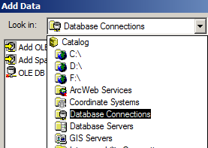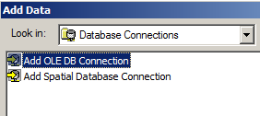

- Open ArcMap and click on Add data. Choose “Database connection” and then “Add OLE DB Connection

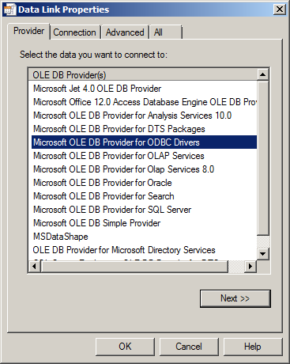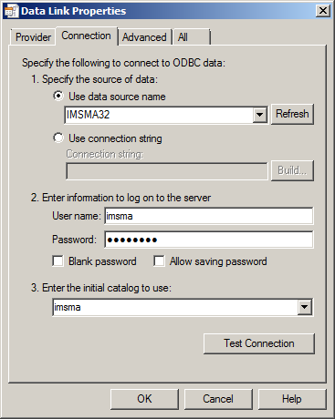

- Choose the Microsoft OLE DB for ODBC Drivers and click on Next.

- Select your ODBC source, fill in user name and password and choose imsma as Initial catalog. If is also good practice to click on Test Connection.

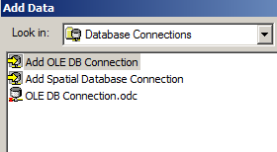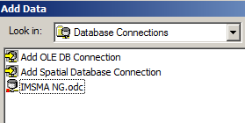

- A new connection is created. Do not forget to rename it to something informative.
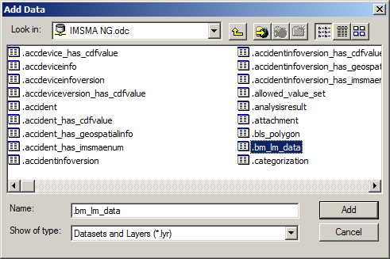
- When you double-click on the OLE DB Connection, e.g. IMSMA NG, all tables and views are available to choose. Select the views you would to add and click on Add.
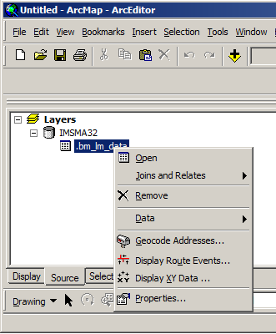

- Right-click on the layer in the Source tab and choose Display XY Data.
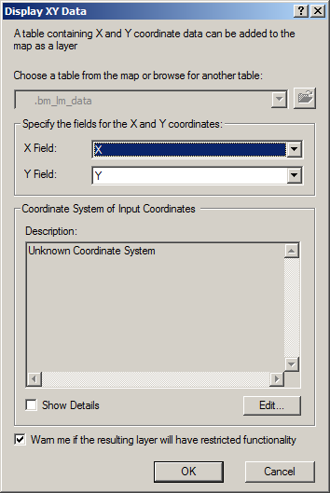

- In the dialog select the columns in your SQL View that contains the longitude and latitude. Specify Coordinate System by clicking on the Edit button.

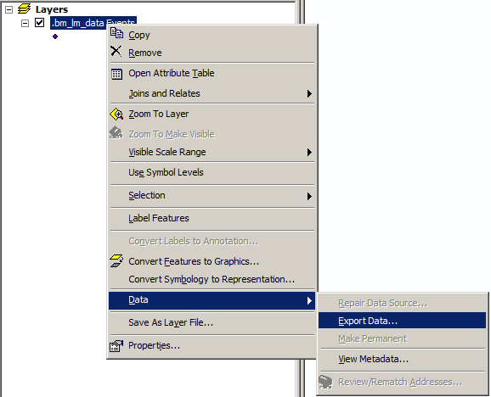

- Your layer is now ready! The final task is to create a shape file from this layer. Right-click on the layer, choose Data and then Export data.

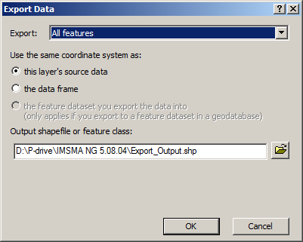

- Specify name and destination of your shape file.

