Country structure import

If you have not been provided a gazetteer than Diva GIS is a good source,
http://www.diva-gis.org/gdata.
Also WikiPedia is a good source of information about the country e.g. admin level 3 (Arrondissement) are not in use anymore in Mali.

ArcGIS preparations
Start by loading the polygon layers in ArcGIS, make sure that the data frame and all layers have the same projection. Save the mxd, e.g. Mali1.mxd, in one folder with the shape/gdb. This will be the background map for IMSMA.
Gazetteer data
Open the gazetteer file/layer. Check what type of features it contains. Often they contain more than towns. The rows that you are interested of are usually coded as P or PPL (Populated places).
Documentation of common format and codes may be found here:
http://earth-info.nga.mil/gns/html/gis_countryfiles.html
Delete the rows you are not interested of this time. Load in ArcGIS, if your data is in an Excel file then the START toolbar has nice functions for loading Excel files and make a point layer of it. There are standard ArcGIS functions too of cause for this.
All types of input data
Next thing to do is to make a spatial join so you know in which country structure area the towns are.
In most cases this in not provided down to lowest level in the original file.
In the case of Syria the spelling of the district name were not consistent between the different files and therefor you might need to use spatial join at other levels too.
Note that when you join you might t loose or change the spelling of names

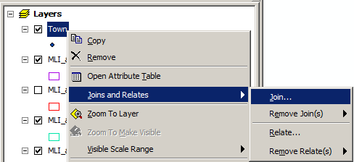
Right-click on the town layer and chose Join.
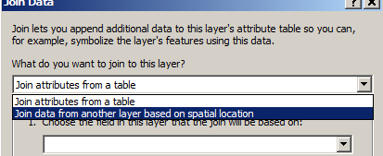
Change type to Spatial location and the type is inside.
Save the result as a shape file as documentation.

Exporting the files to next tool
When exporting from ArcGIS to shape file the export function cannot handle code pages. There might to be ways to change in the registry but this is not a recommended action.
Open the attribute table and select all rows (Ctrl+A).
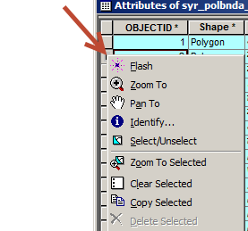
Right-click at the row selector and choose Copy Selected. Paste (append) into an Excel file or Access table.

Preparing the files with Access
I use Access as my data quality check tool and if necessary editing.
It is important to verify that names are unique at each node e.g. in the same subdistrict there should not be 2 villages with the same name. If there are then edit the names until unique e.g. Nmae-1, Name-2.
You also need to verify parents are unique based on name, if not you need to use grand parents etc.
Independent of the source of the Gazetteer and even if they say it has excellent quality you need to verify if they are unique on names.
Be aware of it is very easy to get odd characters. E.g. in the case of Mali é got Ú and ï got ´
If you are going to use alternative names in other languages than English e.g. Arabic then exporting from ArcGIS does not work.
http://www.guidgenerator.com/ is an online GUID generator if you do not want to use Access.
The columns that have s to be set are clnGUID, ParentGUID and LevelName.
I also populate LocalID with the identifier/Pcode which could be used for later updates of Country structure. Note that the LocalID is not shown in IMSMA NG (5.08.04).
When I’m done in Access I export the tables to Excel files. I could of cause have read directly from the Access database to with JDBC but I normally export to Excel because then anyone may use the scripts.

Preparing the scripts
Create a new folder in C:\IMSMAng\migration\data and copy Excel files + scripts there. I adopt the scripts to the data files I have. What I have experience so far that creating the country by import is not working (sometimes?!?) and therefore I create it manually.

Preparing the IMSMA database
Create an “empty" database by running C:\IMSMAng\database\install_initial.bat. I have created my own special start up database that includes some saved searches so I start up by restoring it.
Start the client, add country levels, country and make other changes as requested.
Verify which coordinate systems you have activated, add SHA/CHA to Hazard MA type, etc.
Exist client and take backup.

Running the scripts
Edit C:\IMSMAng\migration\conf\migration.properties
MIGRATION_NAME=IMSMA
MIGRATION_FROM_TYPE=5.3
MIGRATION_TO_TYPE=5.3
MIGRATION_CACHING=FALSE
IMPORT_DATA_DIRECTORY=/data/CS_Import_Mali
PROCESSING_DIRECTORY=/data/CS_Import_Mali
MIGRATION_ORDERING_FILENAME=GazetteerOrdering.txt
Then click on C:\IMSMAng\migration\ Migration.bat and the import will start.
Read migration_history.log and verify that there are no error messages and that the expected number of records were created. migration_stacktrace.log should be empty.

Preparing IMSMA NG
Delete the sandbox and start the client. Verify that everything looks OK, import the map and take backup.

