Odd lines in GIS
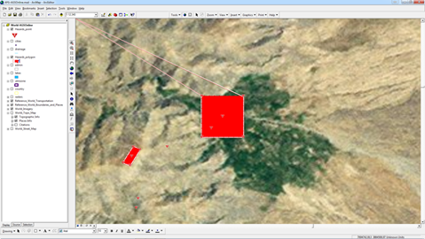

Applies to
- IMSMA ^{NG} 5.06.02 and above

Exceptions
No exceptions are known.

Reason
We have not found one clear reason but the solution has satisfied all countries so far so no more time has been put at find the exact reason.
Note the artefact lines starting from the extremity of the polygon and kind of go around the world.

Solution
- Changer the outline of the polygons to simple style.

